A000-Afr-Benin-Plaque-Edo artist-kingdom court style-Nigeria- Copper alloy-Mid-16th to 17th century [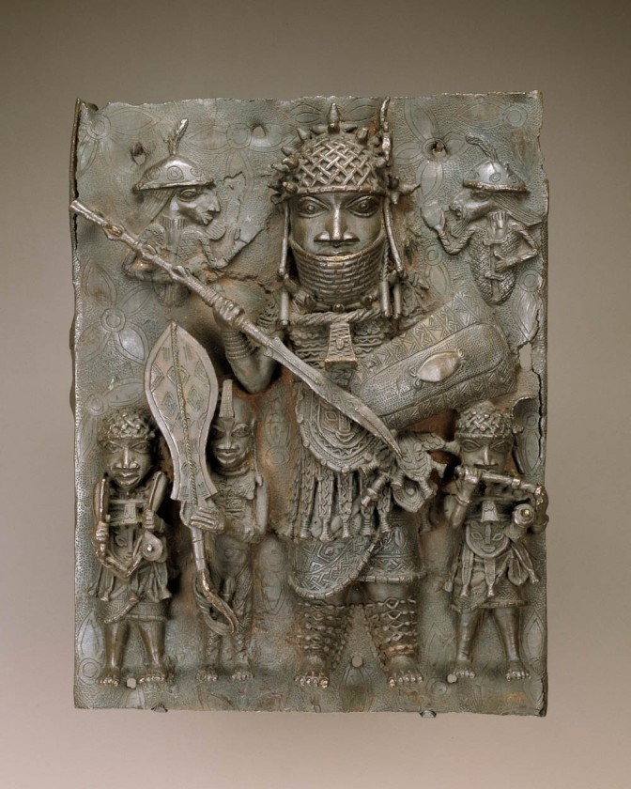](http://africa.si.edu/wp-content/uploads/S20070046Web.jpg) Benin-Plaque-Edo artist-kingdom court style-Nigeria- Copper alloy-Mid-16th to 17th century

**Case no.: 6**

**Accession Number:**

**Formal Label:** Benin-Plaque-Edo artist-kingdom court style-Nigeria- Copper alloy-Mid-16th to 17th century

**Display Description:**

Musicians and a court page holding a fanlike sword (eben) flank a high-ranking warrior, possibly a war chief or the oba. The half figures depict Portuguese soldiers or traders

**LC Classification:** N7399

**Date or Time Horizon:** 18th century

**Geographical Area:** Djougou, Benin

**Map:**

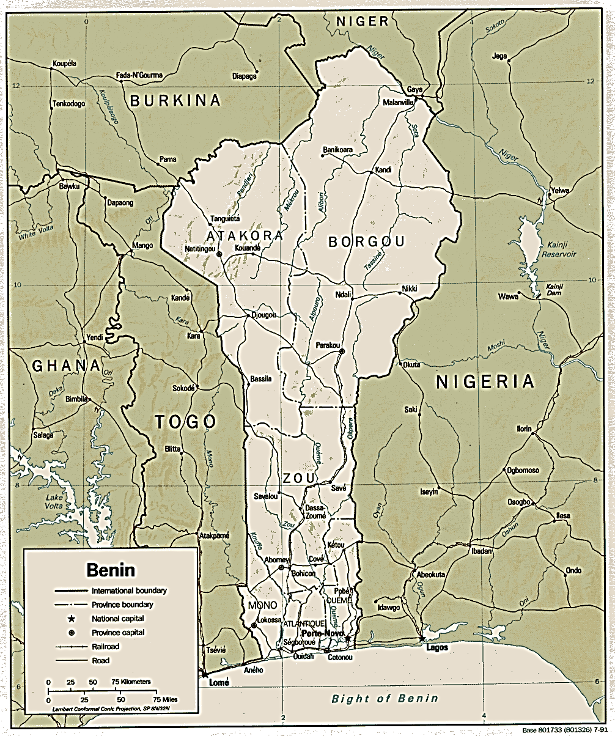

https://www.africa.upenn.edu/CIA_Maps/Benin_19841.gif

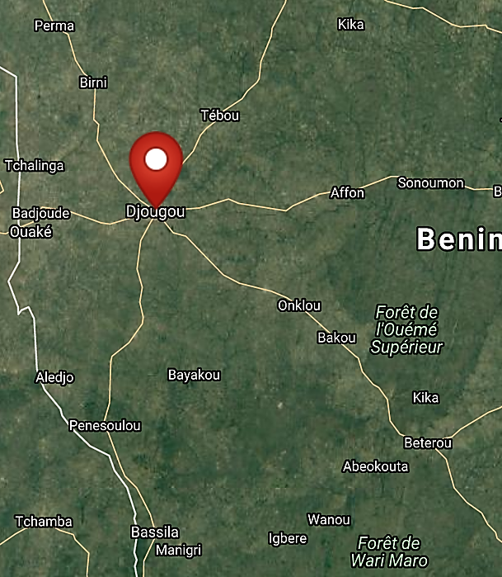

**Maps of Djougou. Benin. After http://latitude.to/map/ng/nigeria/cities/benin-city**

**GPS coordinates: 6º29º42'34.67" N 1º40'4.42" E**

**Cultural Affiliation:** Benin

**Media:** Copper alloy

**Dimensions:**

**Weight:**

**Condition:**

**Provenance:** A similar example was purchased with funds provided by the Smithsonian Collections Acquisition Program, 82-5-3

**Discussion:**

**References:**

Dark, Philip J. 1973. *An introduction to Benin art and technology*. Oxford, Clarendon Press.